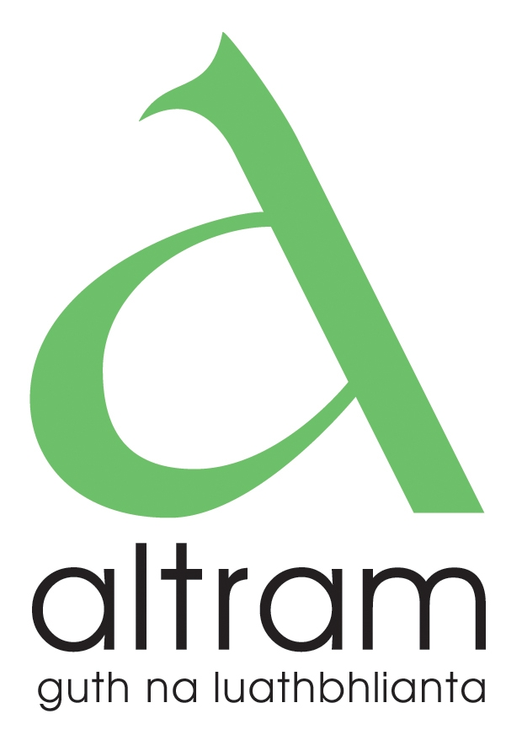

Job Description: Funding & Engagement Officer funded by DE

Responsible to: Manager and Management Board of Altram

Contact with: Management Board of Altram
Altram team
Early Years practitioners & management committees
Community/statutory/voluntary agencies
Department of Education

Aims: To oversee the securing of financial support for the organisation and identifying funding opportunities for the Irish medium early years sector.
To support stakeholder engagement and communication activity with Irish medium early years providers.

Key Responsibilities:

- Funding:
Researching and identifying potential funding sources for the organisation and stakeholders, and managing the grant application process for the organisation
- Engagement:
Supporting stakeholder engagement initiatives, such as community outreach, management committee support and training, event planning, and communications.
- Communication:
Developing and implementing communication strategies, creating content for various platforms, and managing media relations.

- Relationship Management:
Building and maintaining relationships with funders, partners, and stakeholders.
- Administrative Support:
Providing administrative support for funding and engagement activities, including data management, budget overviews and reporting.

GENERAL DUTIES

- To work as an active and integral part of the Altram team
- To be flexible regarding working hours
- To input into Altram website
- To ensure publications and support materials are stored in organised manner
- To undertake such other duties as shall be required from time to time.

Hours: 37.5 uaire sa tseachtain

*Part time hours can be accommodated-ideally no less than
25hours a week-but other considerations may be given to
accommodate work-life balance of a suitable candidate)

Salary: £30,500

ESSENTIAL CRITERIA
The applicant must have:
- A third level qualification
- Experience in using Irish consistently as a means of communication in a working environment or domestic setting
- Competent computer skills e.g. Microsoft Office: word processing, spreadsheets, internet etc…
- Good communication skills in Irish and English
- Ability to build and maintain strong relationships with funders and stakeholders.
- Excellent writing and research skills, to effectively write grant applications and research funding opportunities.
- Organisational and time management skills to manage multiple tasks and deadlines effectively.
- Ability to work on own initiative or as part of a team
- A current driving license or access to a car or other mode of transport, which will enable the applicant to carry out the duties of the post effectively and efficiently

DESIRABLE CRITERIA
- At least one year’s experience of working in the Irish medium sector
- Experience of evaluation systems, data collection and reporting
- Flexibility in working hours if required

